**­­­**

Class 7

**Lecture 2**

**Basic Programming**

**(String, Array)**

**Programming**

**&**

**Algorithm**

**Lab Objectives:**

* What is String?
* What is Array? Type of Array.
* Overview of Array Concept.
* Array in Programming Languages.

**What is String?**

String is a set of characters that may contain spaces, characters, special characters and numbers. In programming languages string is used to store sequence of characters. Such as name, address, email, phone number and many more.

Example:

“Tanha Mim”

“Fahad Faysal”

“Dhanmondi, Dhaka”

“username768@gmail.com”

[*A sentence or multiple sentences are also a String*]

“The quick brown fox jumps over the lazy dog.”

“The quick brown fox jumps over the lazy dog. It’s a sentence that contains all of the letters of the alphabet.”

**String in Programming Languages?**

From last lecture we know that in Programming language ‘String’ is a data type. See this example. This is how String is stored in a variable.

String employeeName = “Sharif Chowdhury”;

String emailAdress = “sharif234@gmail.com”;

String Adress = “H-23,Gulshan-2,Gulshan,Dhaka”;

**Data Type**

**String**

**Variable Name**

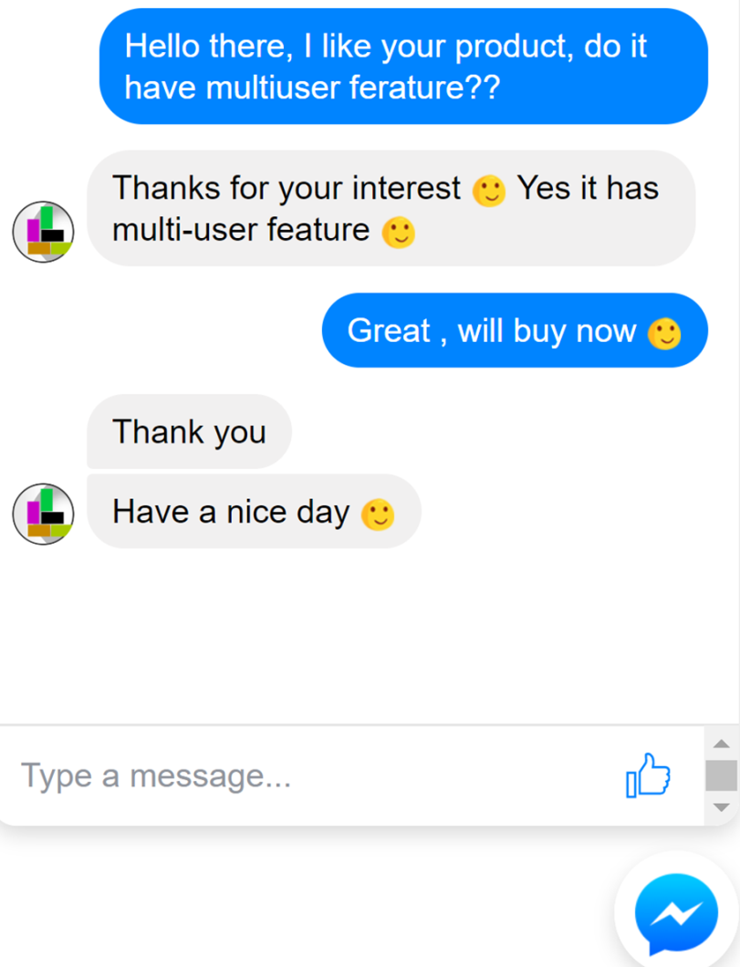

Each message is considered as a String

**What is Array?**

An array is a data structure that contains a group of elements. Typically, these elements are all of the same data type, such as an integer or string. “An array is a sequence of data item of homogeneous value (same type).”

Arrays are of two types:

* One-dimensional array
* Multi-dimensional array.

“An array is a sequence of data item of homogeneous value (same type).”

1. **One-dimensional array(1D)**

Conceptually you can think of a one-dimensional array as a row, where elements are stored one after another.

Just like a row with values

Array:

|  |  |  |  |  |  |
| --- | --- | --- | --- | --- | --- |
| 70 | 73 | 65 | 80 | 76 | 86 |

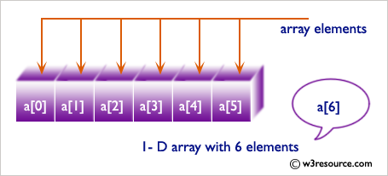

1. **Two-dimensional array(2D)**

The two dimensional (2D) array is also known as matrix. A matrix can be represented as a table of rows and columns. 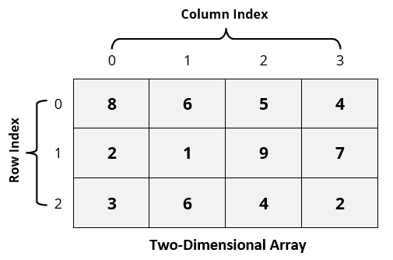

Using 2D array in real life: Chess Board!

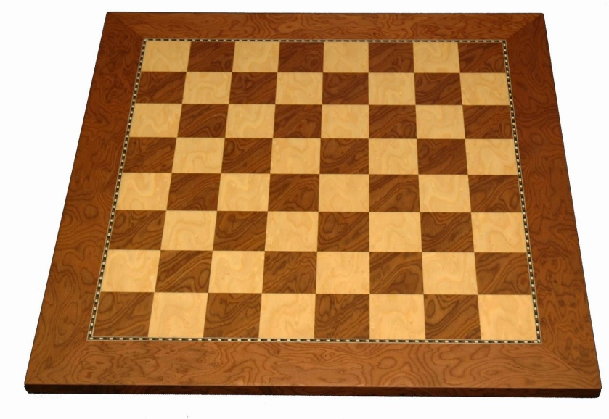

**Benefits of using Array in Programming**

**1D**: Storing and handling same type of data or element efficiently.



**2D**: Dependent element or data can be stored and handles efficiently. Matrix calculation is so much easy using 2D array.

